Chapter 10: Transformation and congruence
Worksheet B

1 Which of the test (SSS, SAS, AAS or RHS) would you choose to test the congruence of these pairs of triangles?

a b
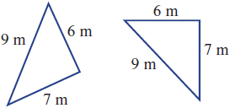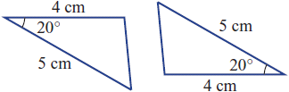

_______________________________________ _______________________________________

2 These pairs of triangles are congruent. Find the values of the pronumerals.

a b
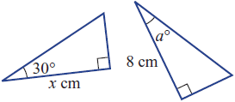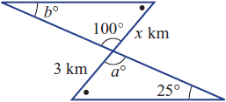

_______________________________________ _______________________________________

_______________________________________ _______________________________________

_______________________________________ _______________________________________

3 For this pair of similar figures, complete the following tasks.

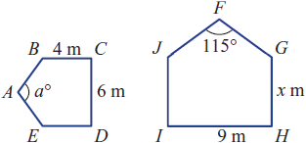

a List the pairs of corresponding sides.

________________________________________________________________________________________

b List the pairs of corresponding angles.

________________________________________________________________________________________

c Find the scale factor.

________________________________________________________________________________________

________________________________________________________________________________________

d Find the values of the pronumerals.

________________________________________________________________________________________

________________________________________________________________________________________

________________________________________________________________________________________

4 Decide if these shapes are similar by considering corresponding angles and the ratio of sides.

a b
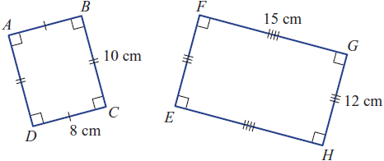 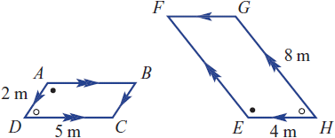

_______________________________________ _______________________________________
_______________________________________ _______________________________________

_______________________________________ _______________________________________

_______________________________________ _______________________________________

5 Decide, with reasons, why these pairs of triangles are similar. State which of the four tests AAA, SSS, SAS or RHS applies.

a b 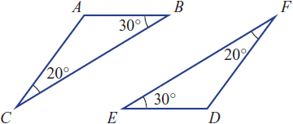 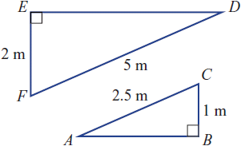

_______________________________________ _______________________________________

_______________________________________ _______________________________________

_______________________________________ _______________________________________

_______________________________________ _______________________________________

6 Given that these pairs of triangles are similar, find the value of the pronumerals.

a b



 

 

 

 

 

